Compiler install directory
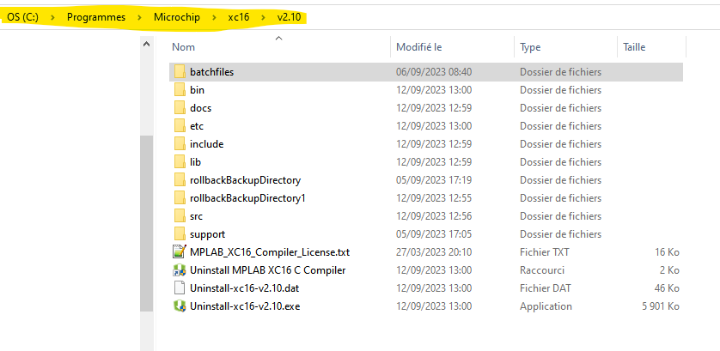
Licence XC16
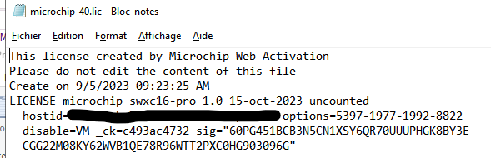
FC9 Global settings
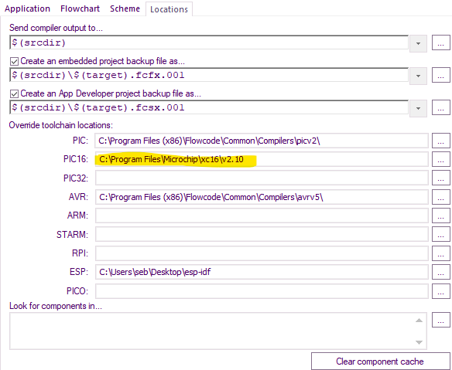

FC9 Compiler options
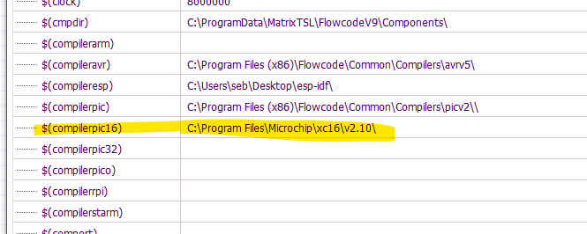
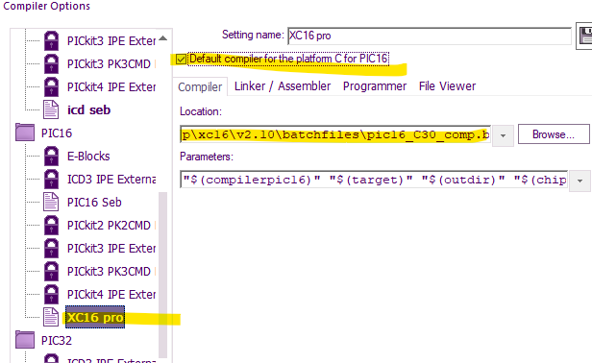
FC9 Compiler message
(in Yellow, this looks strange , support folder can not be in batch files folder )
Target folder: C:\Users\seb\Documents\AAA Microchip
Source name: C:\Users\seb\Documents\AAA Microchip\PIC24FJ256GA705test2.fcfx
Title:
Description:
Device: PIC16.24F.24FJ256GA705
Generated by: Flowcode v9.3.1.36
Date: Tuesday, September 12, 2023 13:29:56
Users: 1
Registered to: lucibel (Xbiotec)
Licence key: QYWWFV
https://www.flowcode.co.uk
Using <XC16 pro> user settings for compiler
Launching the compiler...
C:\Program Files\Microchip\xc16\v2.10\batchfiles\pic16_C30_comp.bat "C:\Program Files\Microchip\xc16\v2.10\" "PIC24FJ256GA705test2" "C:\Users\seb\Documents\AAA Microchip\" "24FJ256GA705"
Le chemin d'accŠs sp‚cifi‚ est introuvable. TRANSLATED : Specified path not found

C:\Users\seb\Documents\AAA Microchip>xc16-gcc -c -mcpu="C:\Users\seb\Documents\AAA Microchip\" -omf=coff -funsigned-char -fno-short-double -Os -I"C:\Program Files\Microchip\xc16\v2.10\batchfiles\..\support\h" -I"C:\Program Files\Microchip\xc16\v2.10\batchfiles\" -std=gnu99 "C:\Program Files\Microchip\xc16\v2.10\".c -o "C:\Program Files\Microchip\xc16\v2.10\".o
COFF format is not supported, please use ELF

Error returned from [xc16-gcc.exe]

C:\Program Files\Microchip\xc16\v2.10\batchfiles\pic16_C30_comp.bat reported error code 0x1

Autoclose turned off

FINISHED

