Flowcode is closed
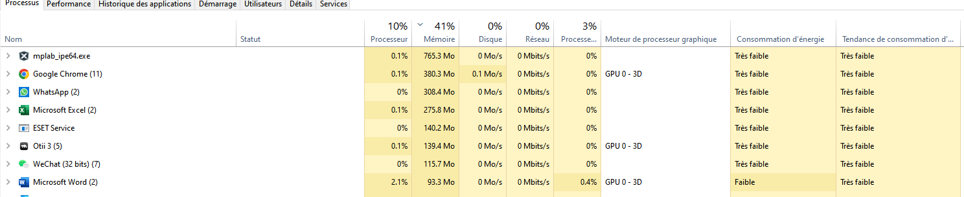
Flowcode is open but no project loaded
Why so many Instances?
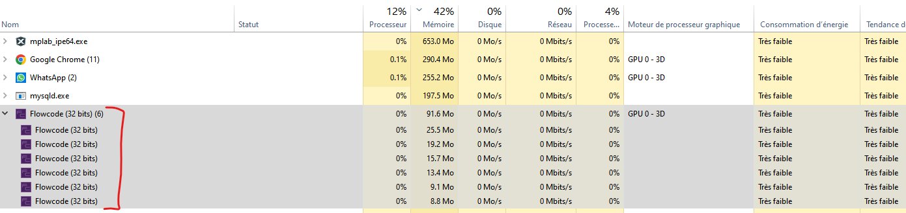
Empty project loaded and saved
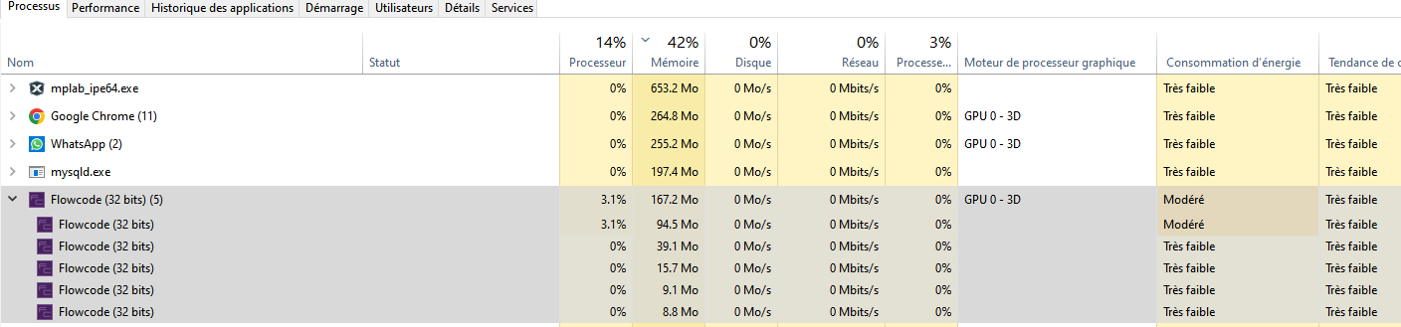
(Big) projet loaded


