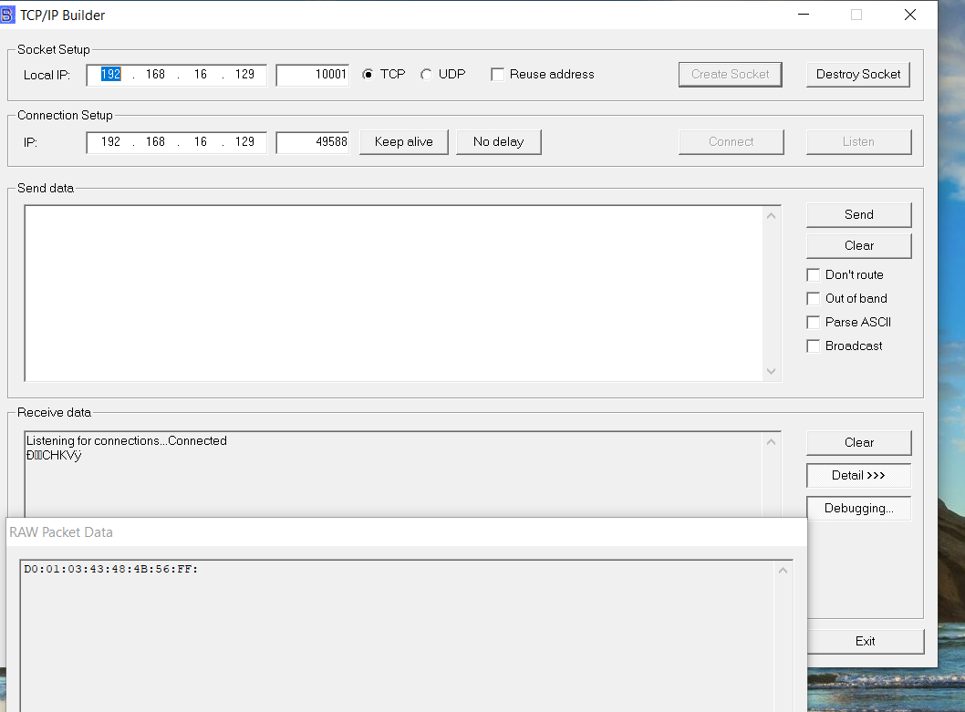
Top is what I’m trying to get.
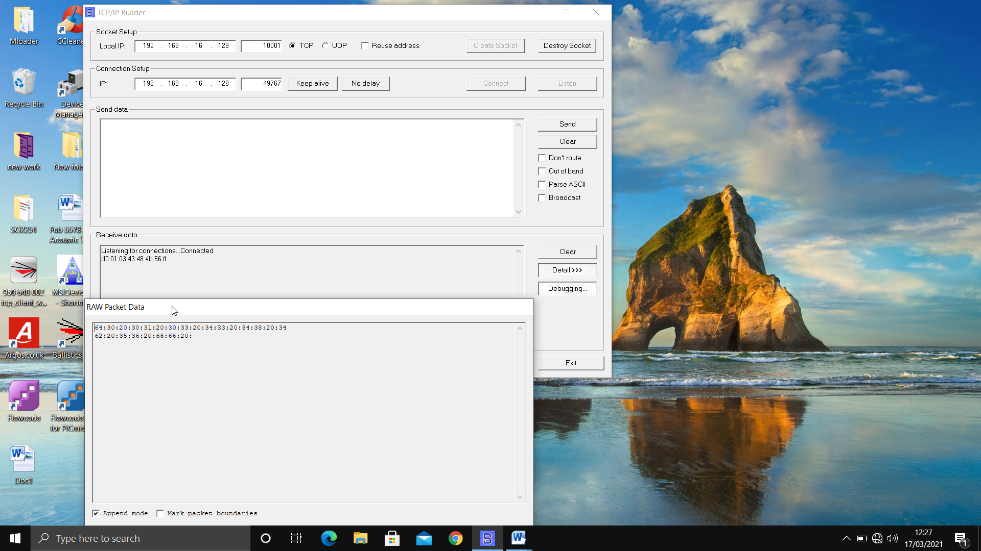

This is what I get in APP on your modified version.

